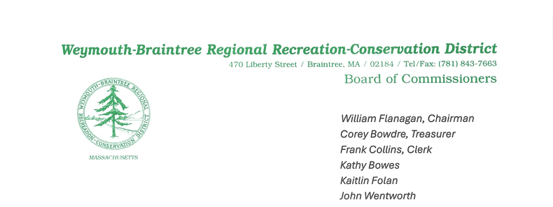
Meeting Minutes
Date: June 18, 2025
Time: 7:00 PM
Called to Order by: Commissioner Flanagan

1. Roll Call
Present:
- Commissioners: Flanagan, Bowdre, Collins, Folan
- Ranger: Keefe
- Mr. Wentworth
Absent:
- Commissioner Bowes
Guest Speakers: None

2. Approval of May Meeting Minutes
Commissioner Flanagan raised a question regarding the quantity of seed purchased. Ranger Keefe clarified that 100 lbs of seed had been spread and 50 lbs are being held for fall. In addition one spelling error was corrected. Commissioner Collins made a motion to approve the minutes as amended; Commissioner Bowdre seconded. Motion passed unanimously.

3. Treasurer’s Report – Presented by Ranger Keefe
- A payment of $35,171 was made in 2025 for retirement expenses, although it was budgeted in 2024.
- The park tractor is currently being serviced. Repairs may total up to $5,000, though the warranty is expected to cover a portion.
- Remaining cash obligations for FY25 are approximately $35,504, which aligns with the approved budget.

4. Chairman’s Report – Presented by Commissioner Flanagan
- Recognized the extensive work performed by the Rangers.
DCR Grant FY25:
- Ranger Keefe collaborated with Mr. Michael Downey at the state to submit an application for a $21,800 DCR grant on May 20, 2025, which was approved on June 2, 2025.
- DCR will fund 75% ($16,363), with the park providing a 25% local match ($5,454).
- The Commission previously approved $7,000 at the May meeting, which will cover the match.
- Plans include purchasing and planting weeping willows outside the meadow perimeter on the abutters’ side.
Meadow Revitalization Plan:
- Commissioner Flanagan presented a summary document outlining conservation efforts, invasive species removal, and habitat restoration.
- Commissioner Collins made a motion to post the document on the Commission website; seconded by Commissioner Bowdre. Motion passed unanimously.
Commissioner Reappointments:
- Commissioner Bowes has been officially reappointed.
- Mr. Wentworth is awaiting confirmation from the Mayor’s Office.
Acknowledgement of Mayor Hedlund:
- Mayor Hedlund has announced his resignation effective July 15, 2025.
- The Commission extends its gratitude for his years of support and wishes him well in his retirement.

5. Supervisor’s Report – Presented by Ranger Keefe
- #10: Ongoing review with John Oliveri Insurance regarding outstanding payment of $3,952 to Cabot Insurance/IFPS Corporation.
- #12: Debris clearing and tree work performed in the “old meadow”; goal is full clearance in FY26.
- #15: CS Kelley Land Surveyors completed boundary staking; Commissioners Flanagan and Folan met with abutters regarding invasive removal plans.
- #17: DCR grant submitted May 30, 2025 and approved June 2, 2025.
- #20: Auctioned items generated $2,586 in revenue.
- #22: Tractor is disabled; repair costs expected up to $5,000. Commissioner Flanagan moved to approve expenditures up to this amount from the Equipment Fund; seconded by Commissioner Collins. Motion passed unanimously.
- #23: DCR representative Michael Downey visited the park on June 10, 2025.
- #24: Zoom meeting with Braintree Army Corps of Engineers confirmed CPC funds for Smelt Brook fish ladder project.
- #25: Wildland Timber completed grant-funded invasive removal in Ranger Trail Meadow and Big Meadow.
- #26: Rangers Keefe and Nikiciuk continue manual cleanup of invasive species following Wildland Timber’s work.
- #27: Fire pit, seating area, and discarded lumber were removed from Birchcroft Road area.
- #28: Former Commissioner Jim Lockhead donated flowers to Weymouth entrance flower box.
- #29: Water & Wetland completed weed treatment. Ranger Keefe to assess need for second application due to regrowth.
- #30 & #31: Potholes filled by Braintree Highway Department and Weymouth DPW respectively.
- #34: Smelt Brook Restoration construction documents received from Army Corps of Engineers; pending signatures from legal and municipal authorities.

6. Friends of Pond Meadow Park Report
- Received a donation of $81.91 for meadow corn and sunflower planting.
- Current account balance: $25,479.03.
- Friends group will fund seeder purchase totaling $126.14.
- Commissioners Collins and Flanagan are exploring donation setup options through the Friends group.

7. Committee Reports
Recorder Recruitment Committee:
- Commissioner Folan reported that interviews were conducted on June 5, 2025.
- The Committee recommends Ryan MacLeod for the Recorder position.
- Commissioner Collins moved to offer the position to Mr. MacLeod; seconded by Commissioner Bowdre. Motion passed unanimously.

8. Old Business
- Updates on the Smelt Brook Project Partnership Agreement and FY25 DCR Grant for invasive species removal were reviewed and noted.

9. New Business
- FY26 DCR grant application is being prepared for submission post July 1, 2025.
- Ranger Keefe has 82 unused vacation hours; Ranger Nikiciuk has 5.
  - Request made to carry over all unused hours into the next fiscal year.
  - Commissioner Flanagan moved to approve the rollover; seconded by Commissioner Collins. Motion passed unanimously.

10. Commissioner & Ranger Comments
- Commissioners commended the Rangers for their exceptional work, particularly in the meadow and conservation areas.

Meeting Adjourned: 8:35 PM

