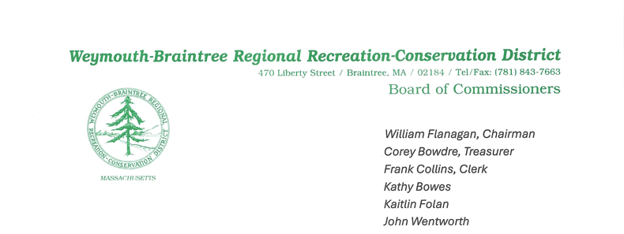
Pond Meadow Park Commission Meeting Minutes
Date: February 19, 2025
Time: 7:00 PM

1. Call to Order & Roll Call
The meeting was called to order at 7:00 PM.
Present:
Commissioners: Bowes, Bowdre, Flanagan, Collin, Folan, Wentworth, Keefe, Joe Kowalski
Supervisory Ranger: Keefe
Guest: Joseph Kowalski, Forester

2. Guest Speaker – Joe Kowalski
- Joe Kowalski provided updates on funding options:
a. State Funding – Two potential funding avenues were discussed:
i. Urban Community Forest Program – This could fund shade trees for the park
ii. Forest Stewardship Grant – This covers more forestry activities with a 75/25 reimbursement rate. In-kind services and internal costs (e.g., park ranger salaries) can be included.
b. Next Steps – Discussed potential spending this year to receive 75% reimbursement. Joe will work with Brion on completing the application. The application requires a detailed budget and background write-up.
d. Invasive Species – A discussion ensued regarding the possibility of removing invasive species and replacing them with native species.
c. Commissioner Flanagan – Will draft a letter to be sent to abutters explaining the initiative.
d. Friends of PMP Meeting (3/2) – Commissioner Flanagan to attend and request funding for meadow seed and harrow tractor attachment.
e. Invoice Payment – The commission reviewed and approved a $1,000 invoice for research and preparation of forestry stewardship options, previously approved by the Commission.

3. Approval of January 15, 2025 Regular Meeting Minutes
- Correction: Commissioner Flanagan noted a correction in the January meeting minutes regarding a credit card charge, which should have been $62.50 instead of $64.50.
- Motion: Commissioner Bowes motioned to approve the January 15 meeting minutes, with the correction. Commissioner Bowdre seconded the motion.

4. Treasurer’s Report
- Checks: Commissioner Bowdre reported that checks will be ordered online.

5. Supervisors’ Report
- #4 Budget – The budget has been submitted to both towns. Commissioner Flanagan discussed the process for constructing the budget.
- #6 Capital Expenditures – Quotes were received for capital expenditures for park building work.
- #8 Five-Year Plan – Ranger Keefe updated the five-year plan, including a $5k pollinator meadow seed project. Commissioner Bowes requested further details on the conex container, as the current one is leaking. Commissioner Flanagan suggested visiting Esker Park to see their conex containers for ideas.
- #9 Payroll Withholding Discrepancy – There is an approximate $8k discrepancy with payroll withholding amounts. Ranger Keefe is working to resolve this issue related to a prior EIN number.
- #12 Army Corps Meeting – A meeting was held with officers from both towns to align on signers and logistics for upcoming projects. Discussions also covered the fish ladder and temporary bridge projects.
- #13 Pollinator Habitat Grant – A $2,500 grant for pollinator habitats was applied for; results will be available in a few months.
- #15 Insurance – Efforts are underway to finalize insurance and resolve overdue notices.

6. Chairman’s Report
- Pollinator Meadow Impact – Commissioner Flanagan emphasized the positive exposure a pollinator meadow will bring to the park. A presentation to the Braintree Rotary is scheduled for 2/20/25 to discuss the plans for the meadow and park mission.
- Project Costs:
  - The estimated cost for the tractor attachment is approximately $5300, and the meadow seed costs will range from $4k to $5K. The total project cost is expected to be approximately $10k.
  - Motion: Commissioner Flanagan made a motion to pursue the pollinator meadow project with vigor. Commissioner Collins seconded the motion.
- Recorder Position – A job description was presented for the new recorder position. A discussion followed regarding whether a commissioner can take the minutes. By-laws will be consulted. Commissioner Bowes suggested adding proficiency in Word or Google Docs as a qualification. Interviews will be conducted by a sub-committee of commissioners.
- March Meeting: Commissioner Flanagan will be unable to attend the March meeting, and Commissioner Collins will lead the meeting.

7. Friends of Pond Meadow Park Report (Presented by Commissioner Collins)
- A $250 donation was received last month.
- The Friends of PMP currently have $34,591.68 in the bank.
- Request: Members are asked to inform Joan if they plan to attend the Friends meeting on 3/2.
- Announcement: Commissioner Bowes suggested placing a donation request in the Beld newsletter.

8. New Business
- Mental Health Awareness Walk (Bay State Community Service):
  - Commissioner Flanagan received a letter from Bay State Community Service, requesting approval to host a mental health awareness walk this spring. They will provide insurance, port-a-potties, trash barrels, and volunteers for cleanup.
  - Motion: Commissioner Flanagan made a motion to approve the walk, pending insurance approval from the carrier. Commissioner Wentworth seconded the motion.

9. Commissioners and Ranger Comments
- Commissioner Bowes & Wentworth – Still awaiting reappointment from the Braintree Mayor.
- Commissioner Folan – Reported reappointment and plans to sign paperwork at Town Hall.

10. Motion to Adjourn
A motion to adjourn was made by Commissioner Bowes and seconded by Commissioner Wentworth. The meeting was adjourned at 9:27 PM.

Minutes submitted by: Kaitlin Folan
Date: February 20, 2025

