
ELECTRONIC WASTE DAY
BRAINTREE & SURROUNDING TOWNS
HOUSEHOLD ELECTRONIC WASTE ONLY / No Hazardous Materials
CASH/CHECK ONLY


Saturday April 26, 2025
9:00am – Noon l 74 Pond Street
ELECTRONIC ITEMS LIST
The following items can be recycled as electronic waste:
$5 Item | $10 Item | $25 Item
- Wires and Cords  - Music Players  - Networking Equipment  - Game Consoles  - Keyboards and Mice  - Electronic Videos  - Portable Digital Stereos  - Cell Phones and Chargers  - Speakers  - Electronic Instrumentation | - VCR/DVD Players  - Computer Towers  - Projectors  - Irons, Toasters, Coffee Makers  - Printers, copiers  - Scanners  - Fax Machines  - Vacuums | - Microwave Ovens  - Monitors  - Laptops  - Air Conditioners  - De-humidifiers  - TV's up to 25"
Most small household items that can be plugged in.
Additional Info: braintreerotaryclub.org/Stories/electronic-waste-day or call Gavin Williams at 781-917-4765

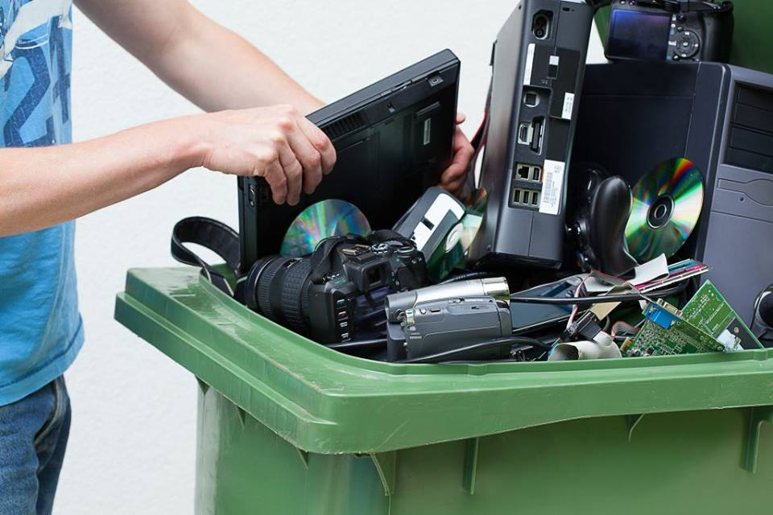
HAZARDOUS WASTE WILL NOT BE COLLECTED AT THIS EVENT. The Braintree Rotary Club is the proud sponsor of this event. Saturday, April 26, 2025 l 9:00am – Noon l 74 Pond Street
ELECTRONICS PRICING:
Cash/Check Only (no credit/debit cards)
Televisions | Over 25” - $35 ea.

EWD Spring 2021

